

SRI LANKA INSTITUTE OF INFORMATION TECHNOLOGY

[**Enterprise Standards and Best Practices for IT Infrastructure**](http://courseweb.sliit.lk/course/view.php?id=137)

**4th Year 1st Semester 2016 (June Intake)**

Name: N.A.I. Dhanushka

SLIIT ID: IT13136666

Practical Session: <WD >

Practical Number : <Lab 2>

Date of Submission: 30/07/2016

Select “Installer disk image file” and browse for “VMware VMvisor Installer ”, and select “Next”.

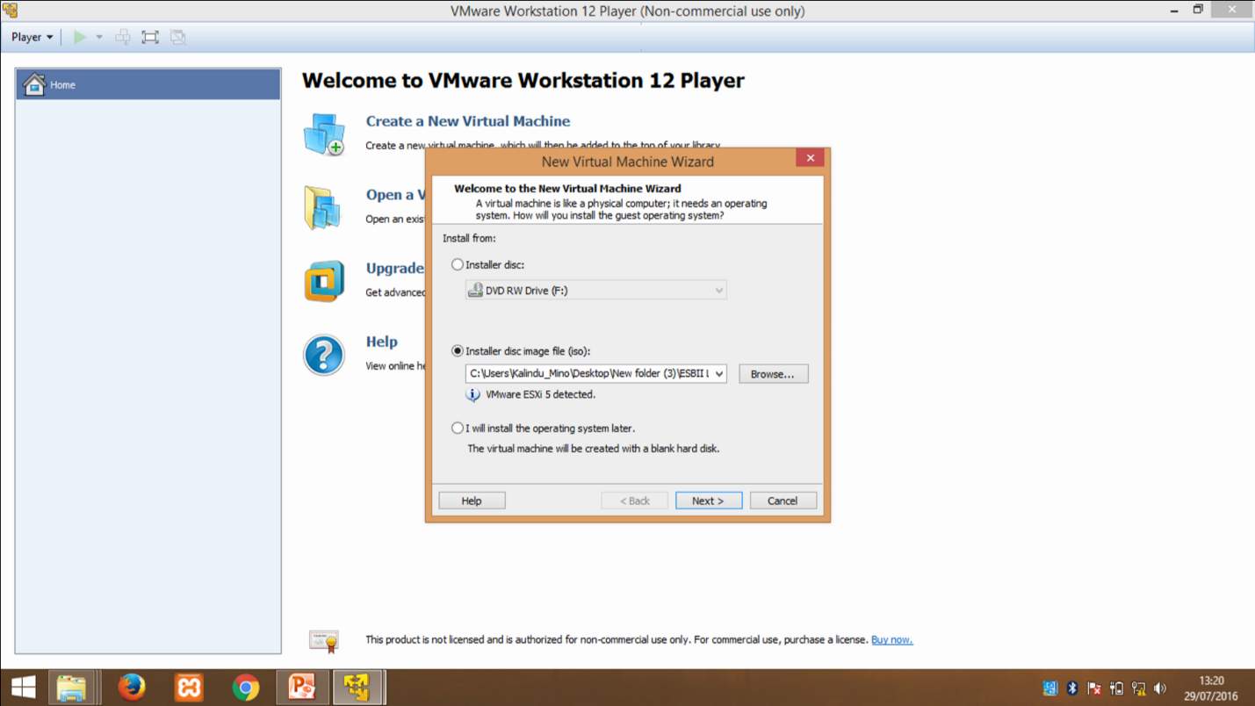

Give Location and select “Next”.

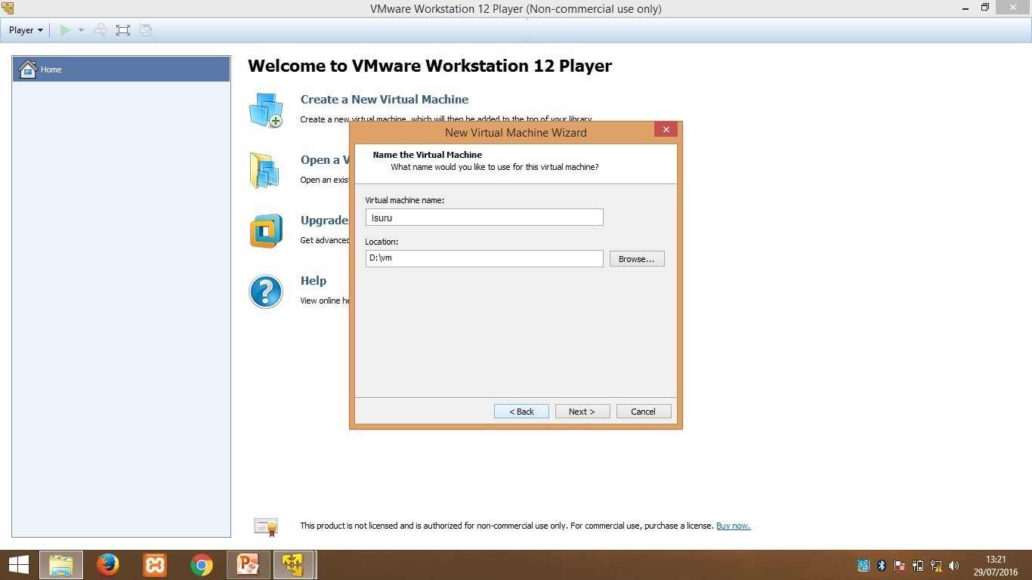

Select “Store virtual disk as an image file” and click “Next”.

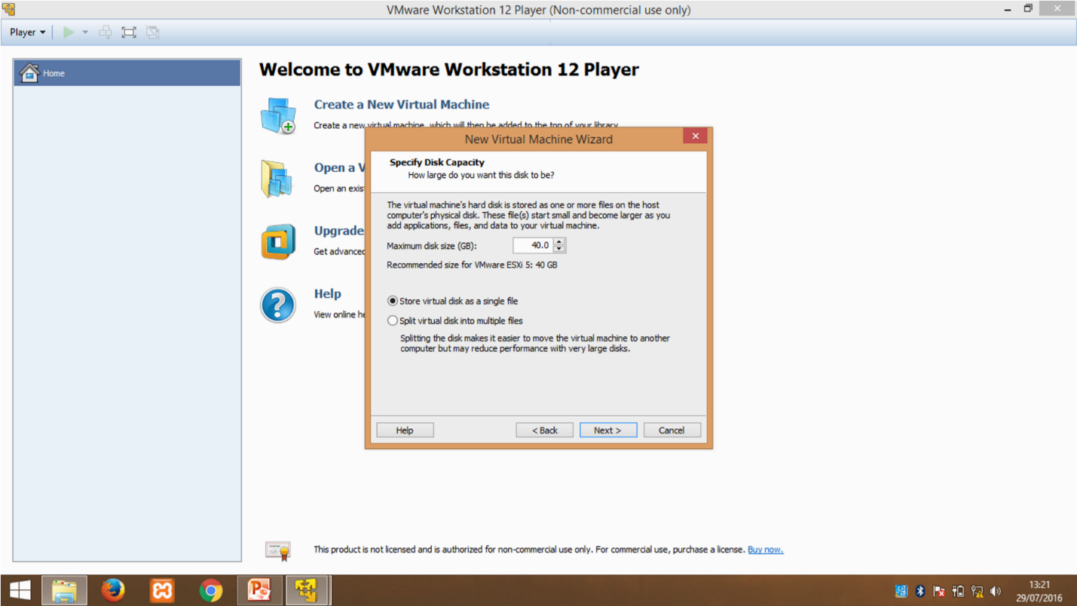

Click “Finish”.

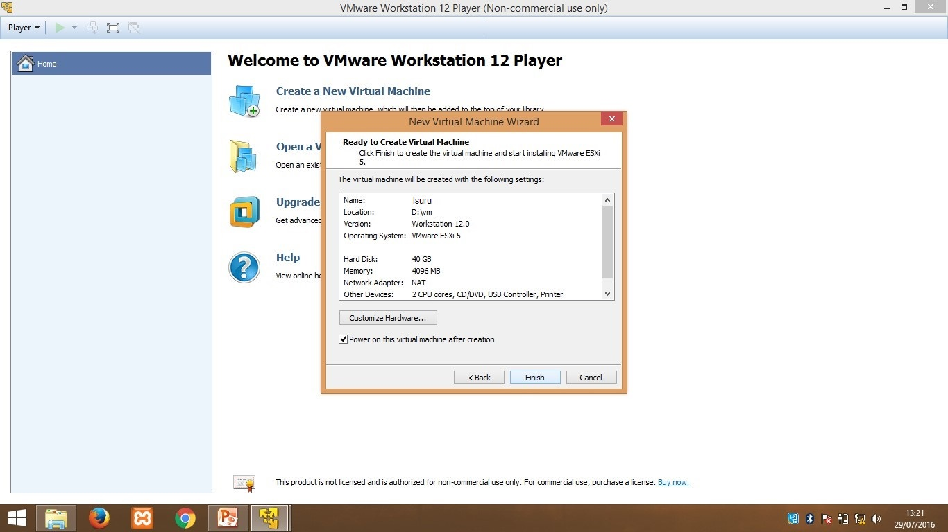

Click “OK”.





Press “Enter”.

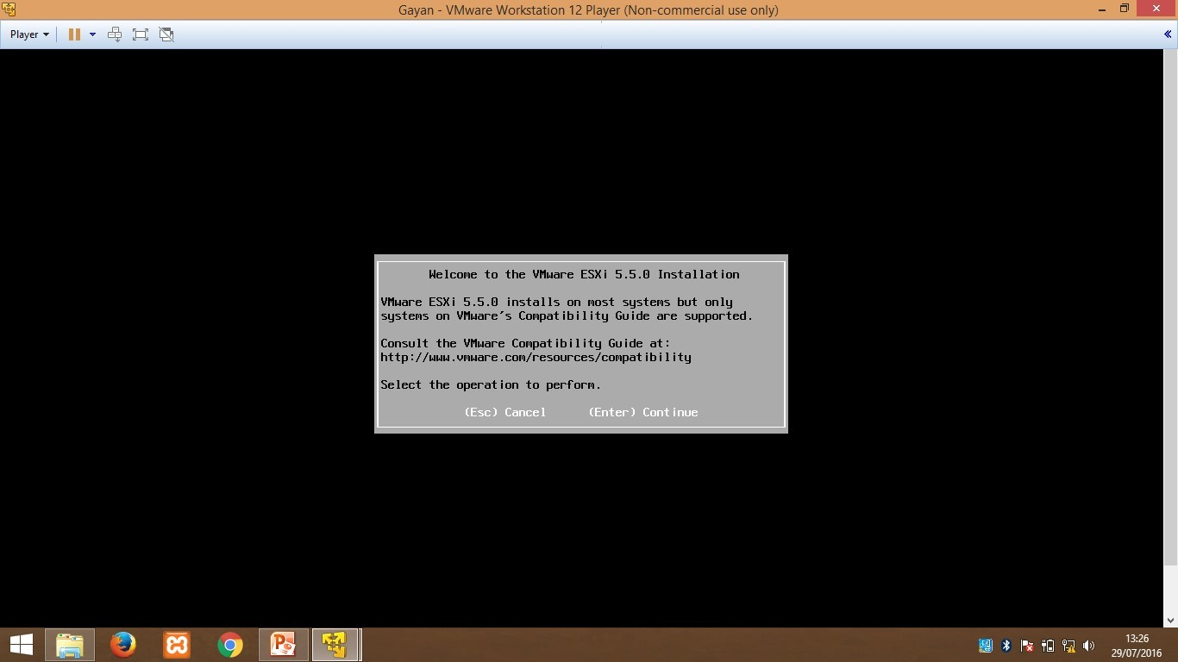

Press “Enter”.

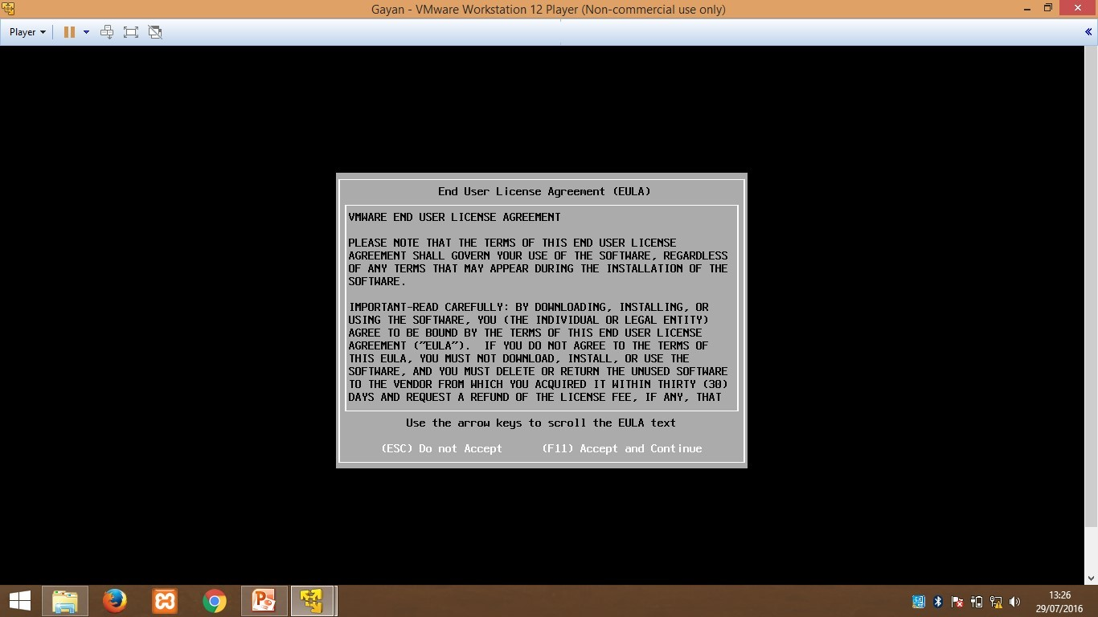

Press “Enter”.

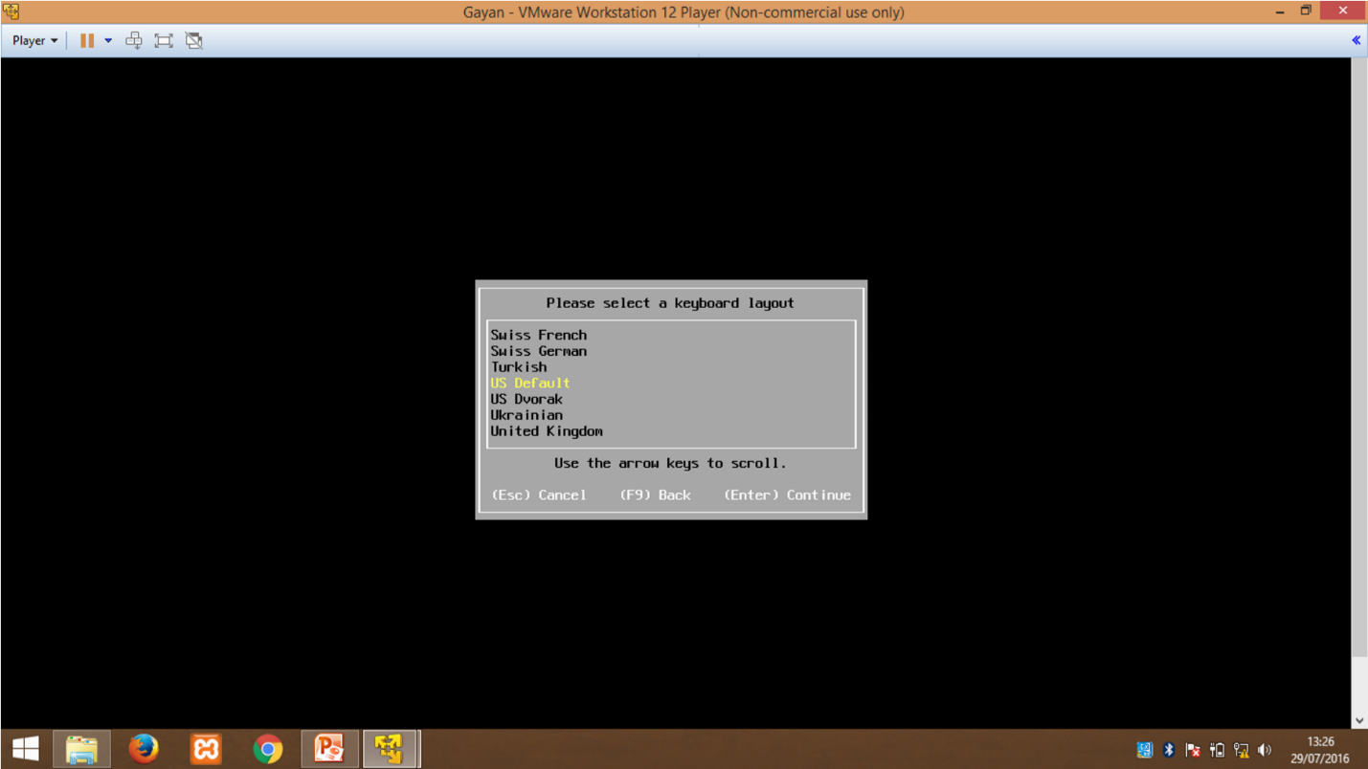

Give a password for “Root password” then confirm it and press “Enter”.

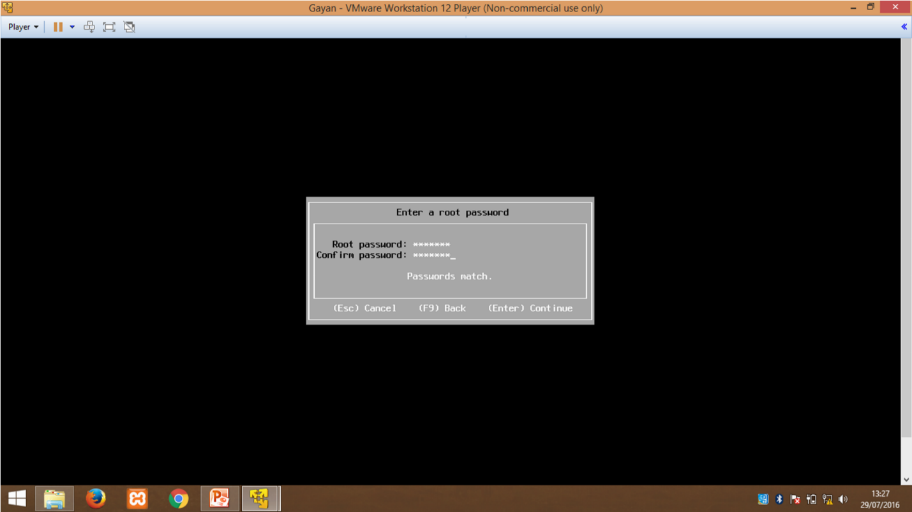

Press “F11” to install.

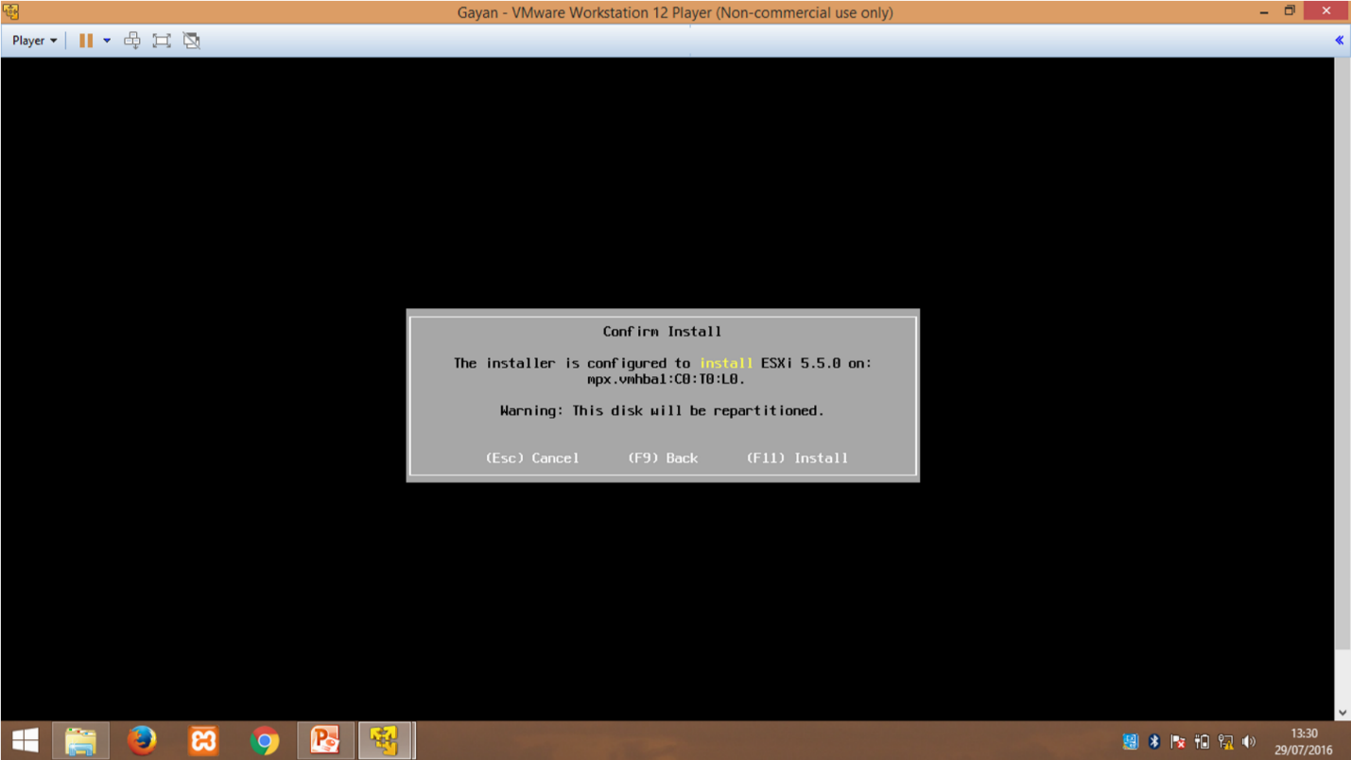

Press “Enter” to Reboot.

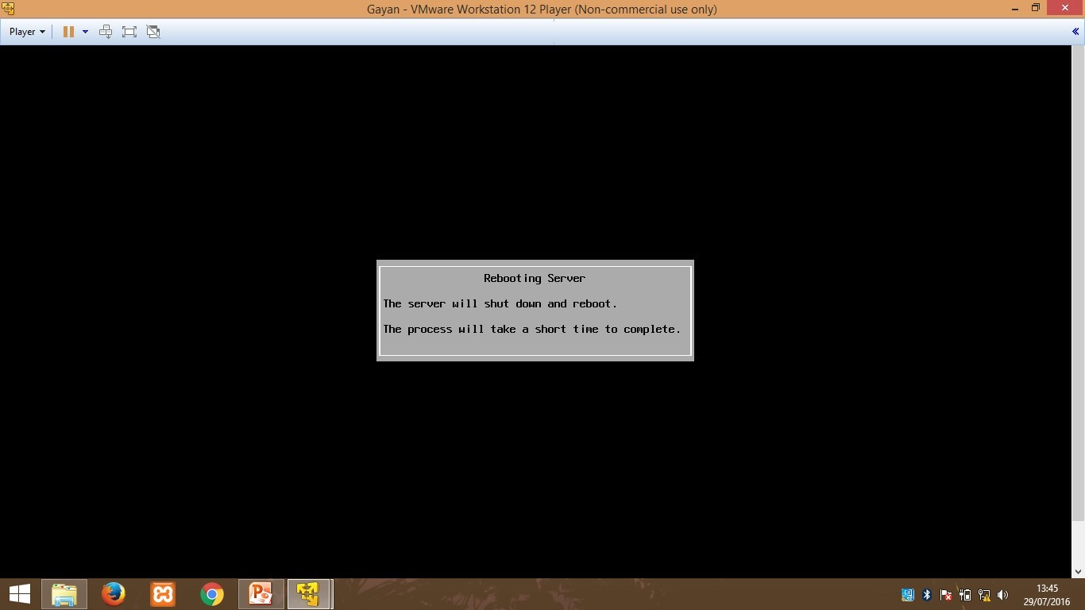

Host IP address is given below go to that link and download “VMware VClient”.

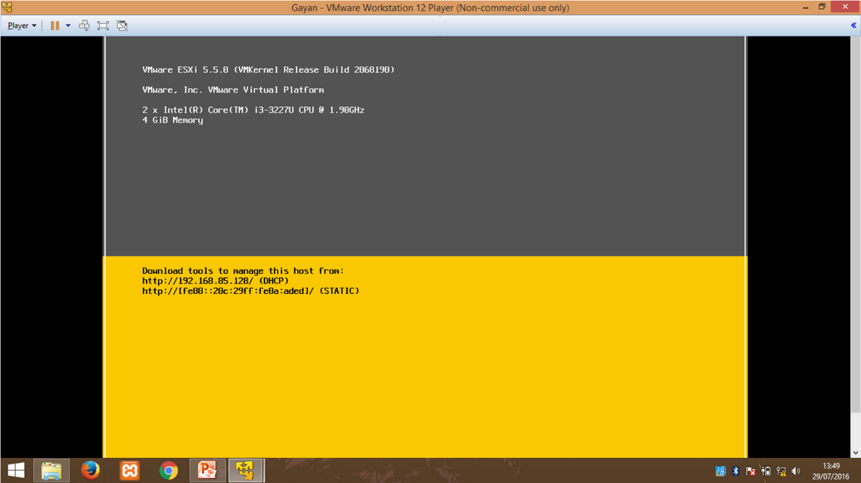

Now go the downloaded file and run it.

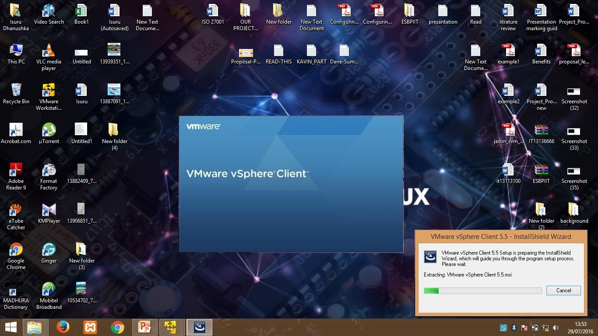

Click “Install”.

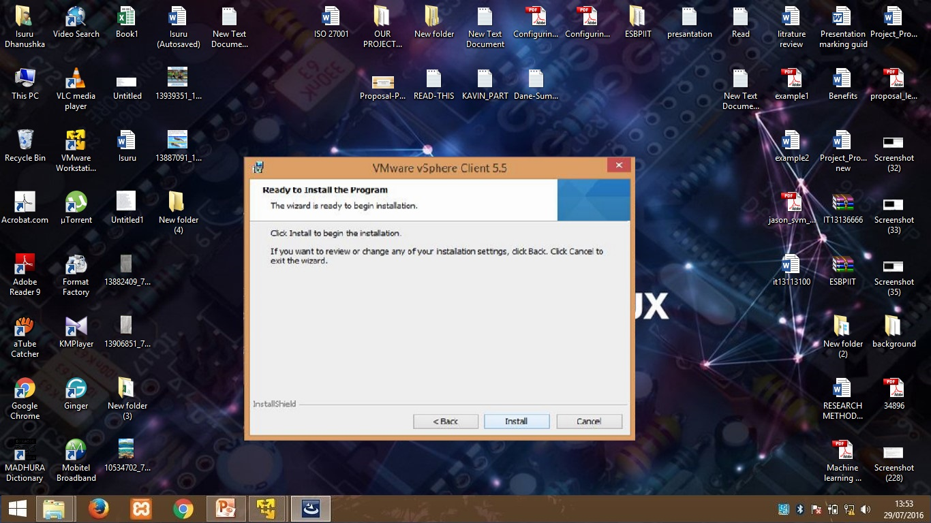

Click “Finish”. VMware VSphere will be on your desktop now, run it.

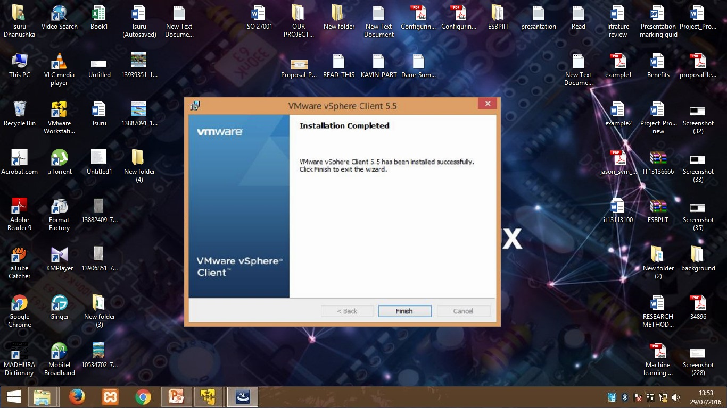

Provide host IP address previously shown and give username as “root” and provide the password you previously gave. Click “Login”.

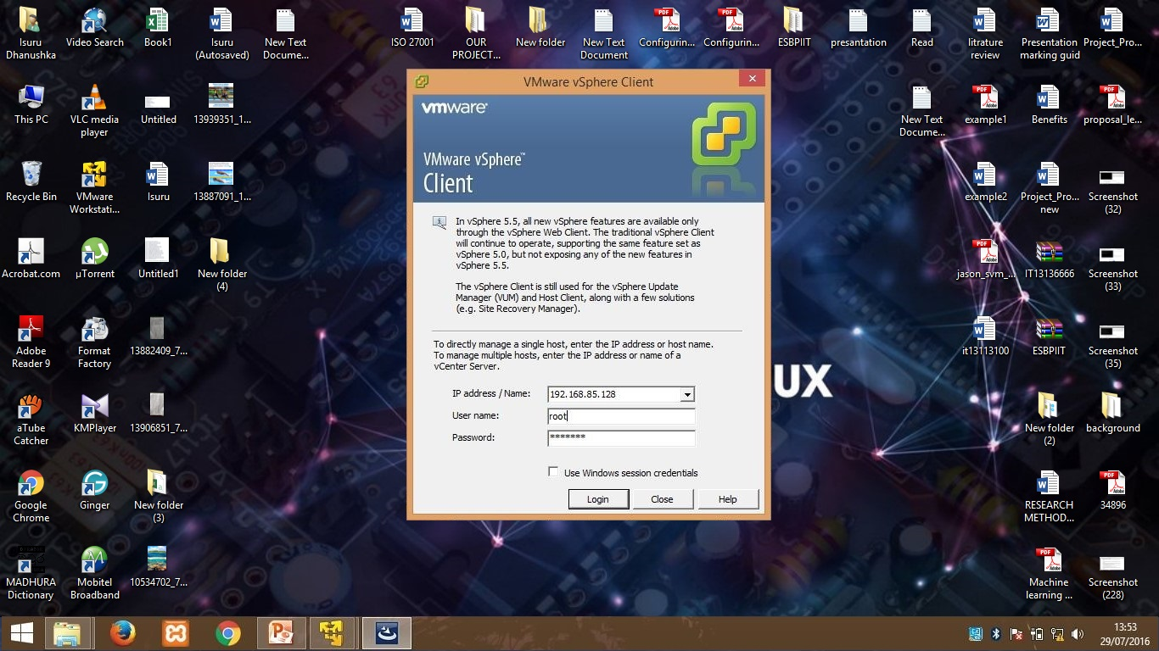

Click “Ignore” for the Security Warning.

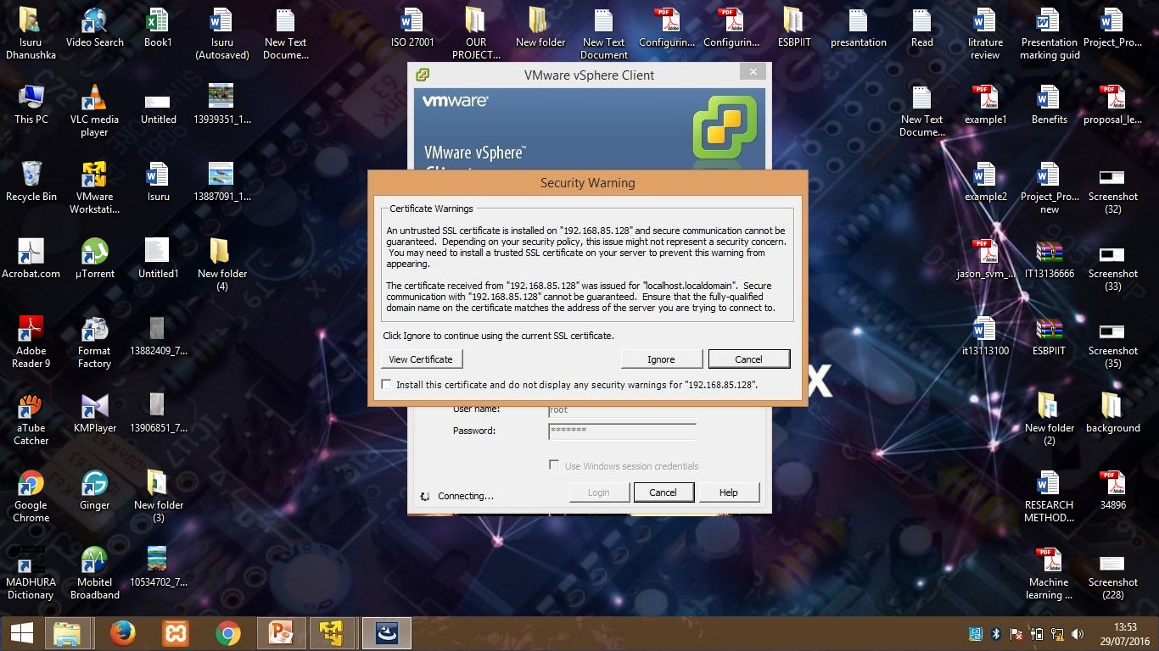

Click “OK”.

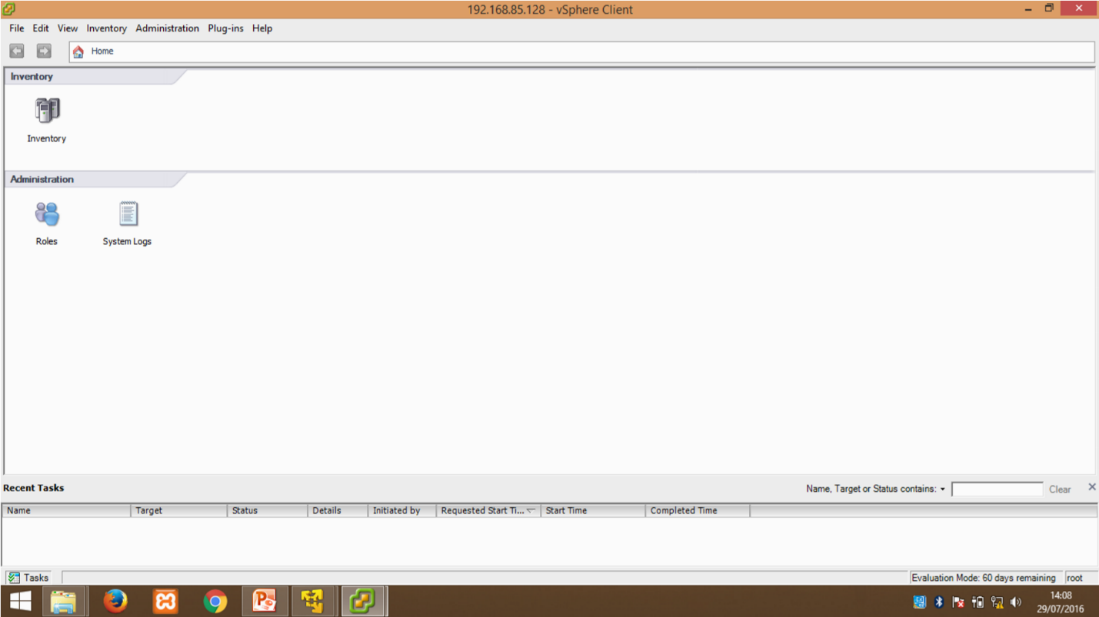

Right click “databases” and select “Browse Database”.

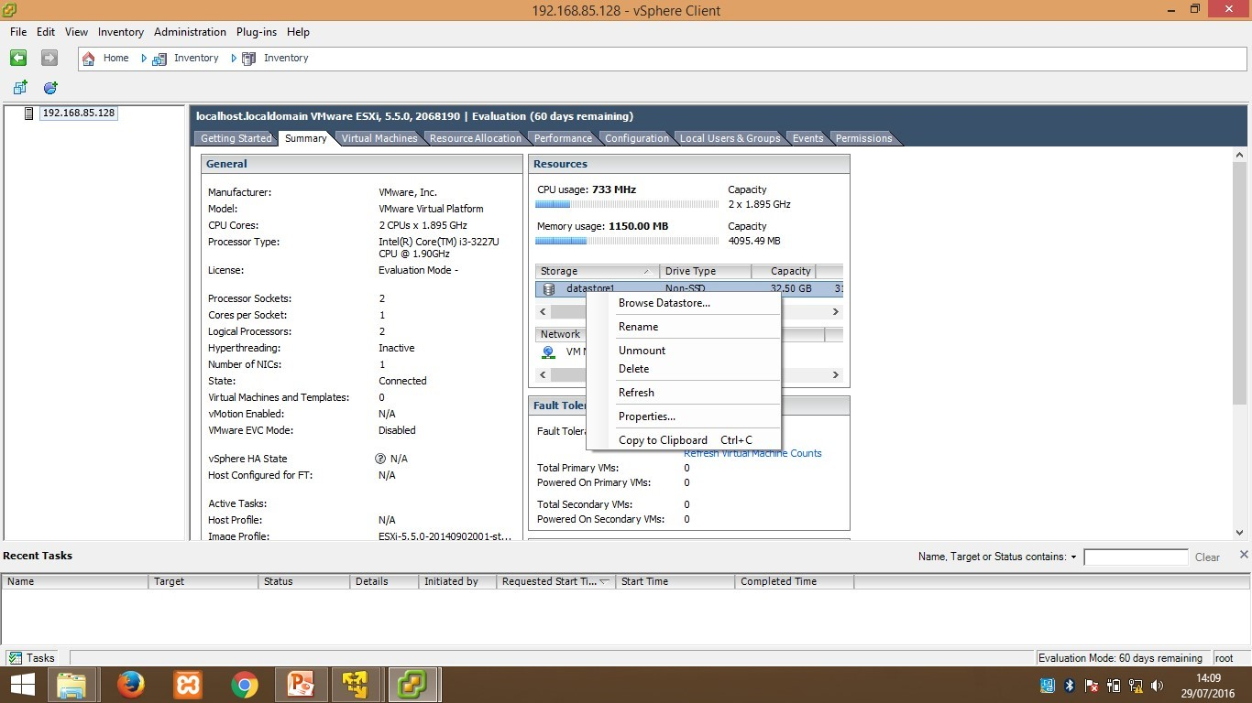

As shown below select “Upload File” and browse for “Kali Linux”.

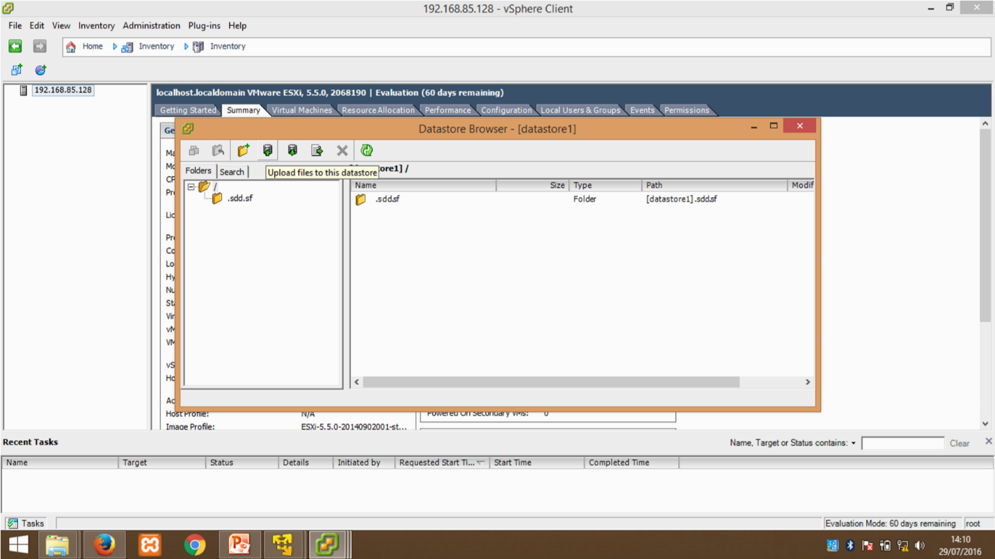

Select “Yes”.

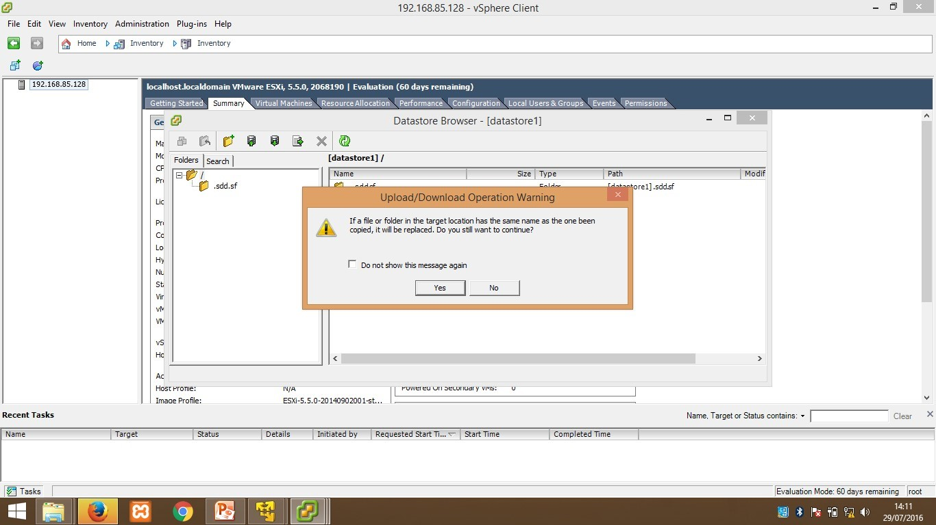

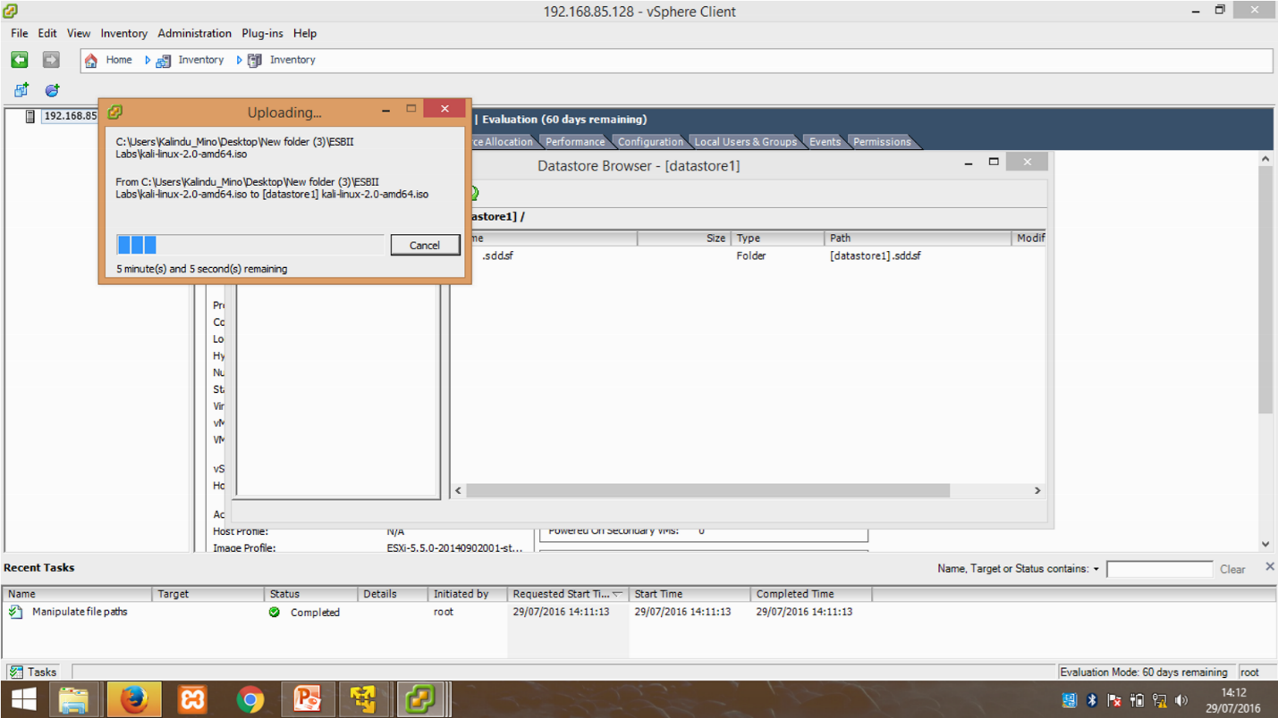

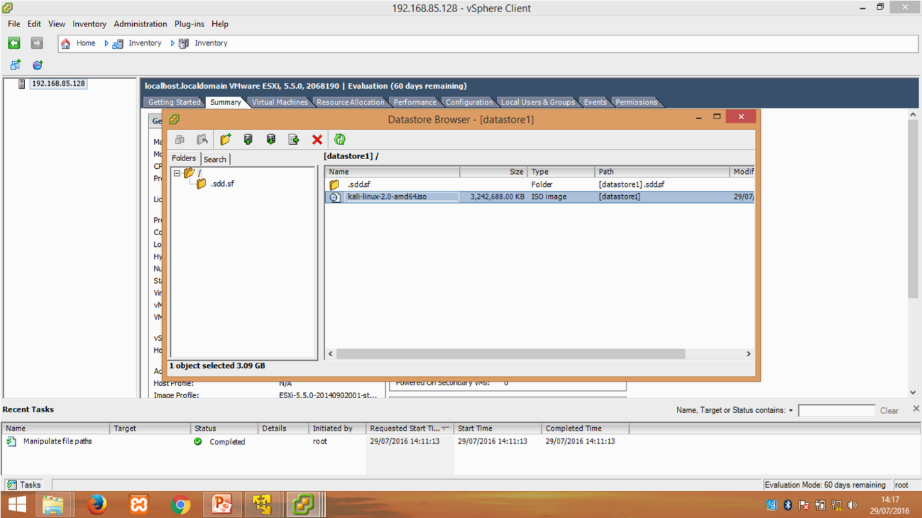

Meanwhile uploading the OS go to the ip address shown on and right click then select “New Virtual Machine”.

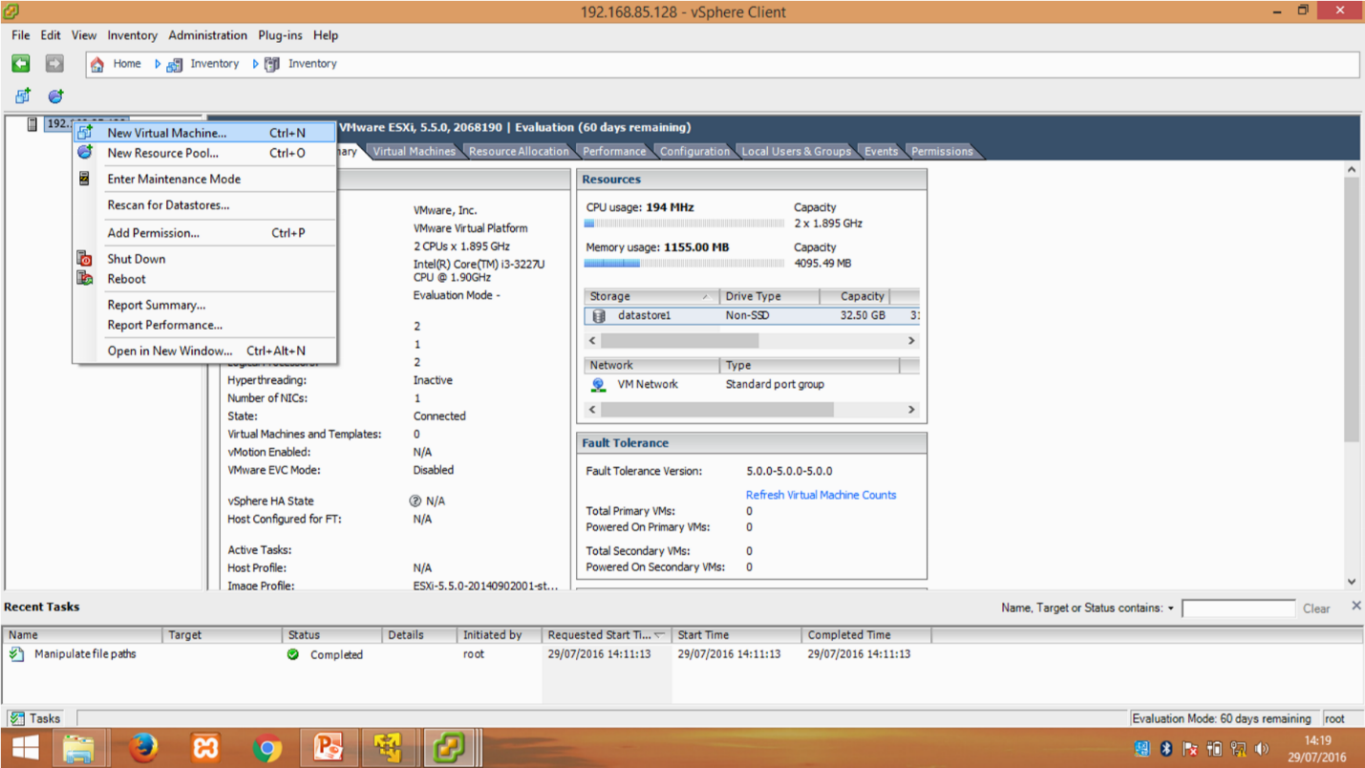

Select “Typical” and then click “Next”.



Give a name to your VM.

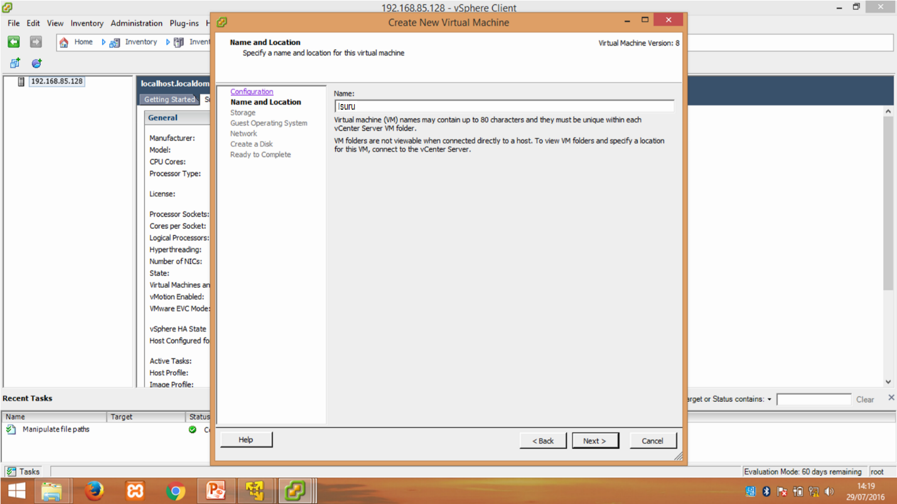

Select “Linux” and from the dropdown select “Other Linux (32 bit)” and Select “E100” as Adapter and click “Next”.

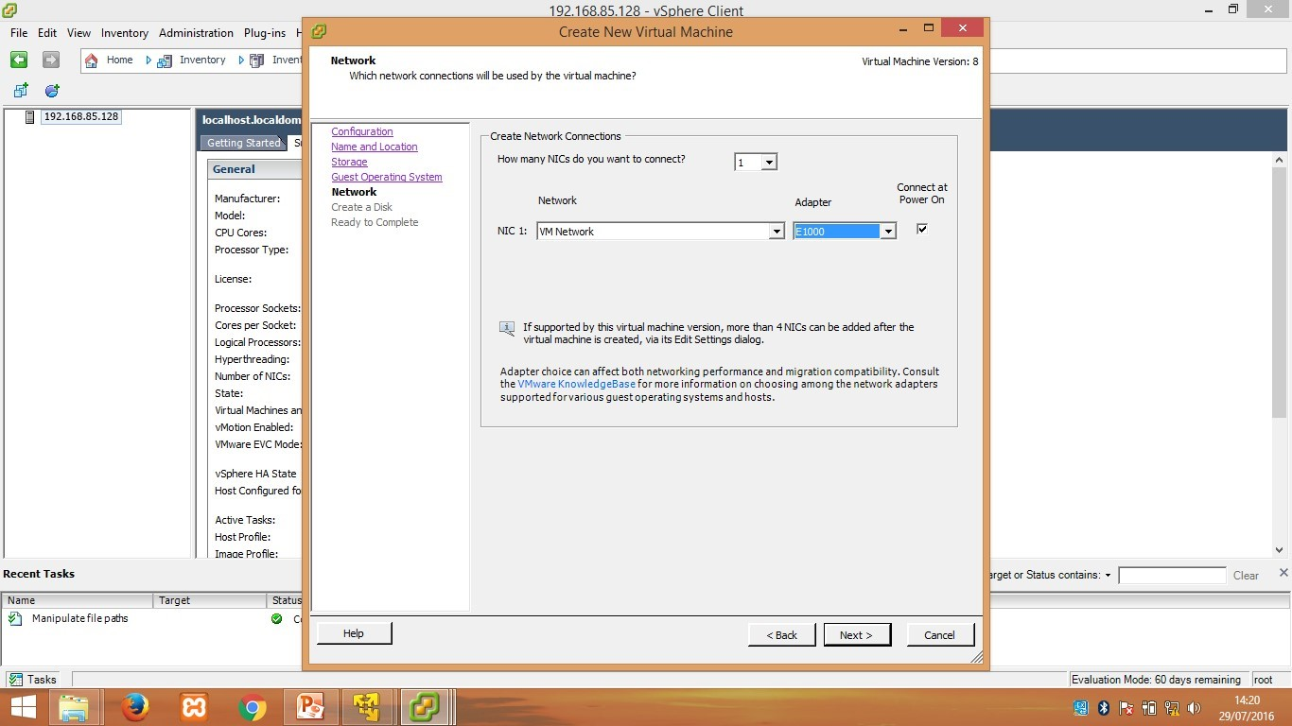

Select “Finish”.

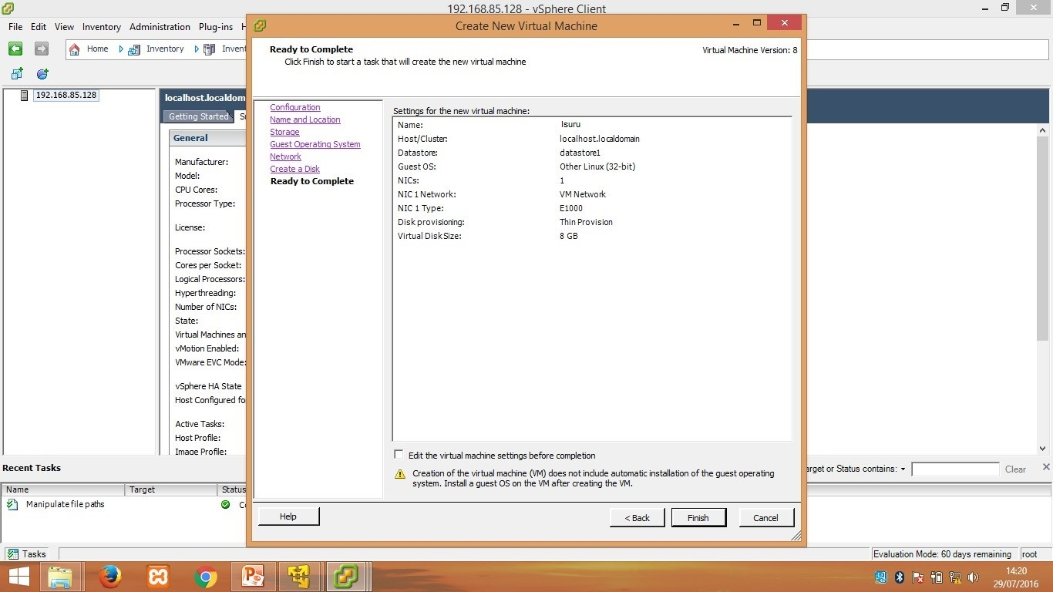

Now you can see **Isuru** is showing under the host IP. & Now right click on **Isuru** and select “Edit Settings”.

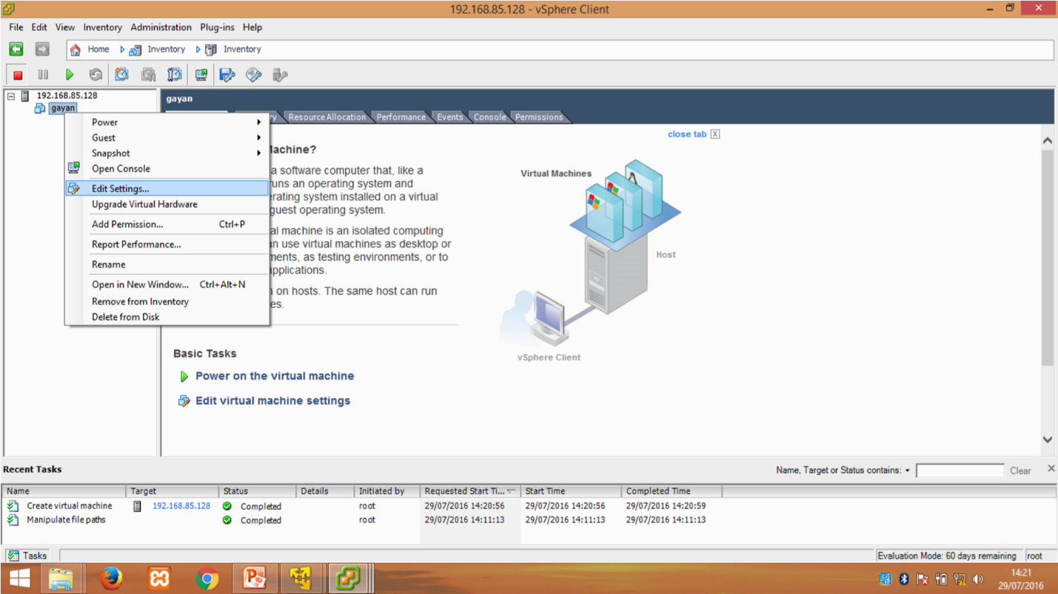

Select “CD/DVD drive 1” and browse Data store ISO file, then click “Host Device”.

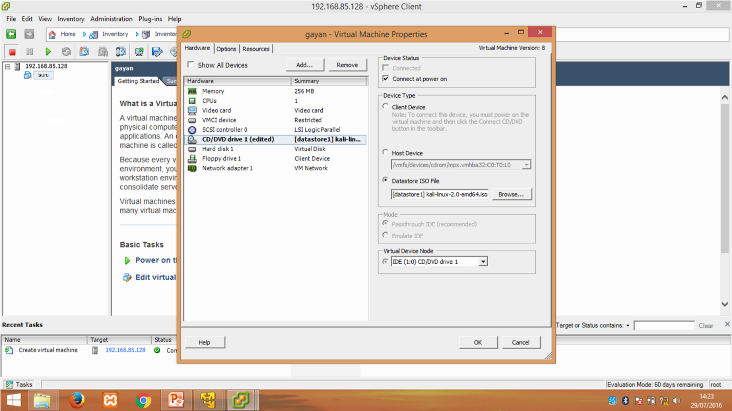

Now the **Isuru** has installed successfully. Click “Power on the virtual machine”.

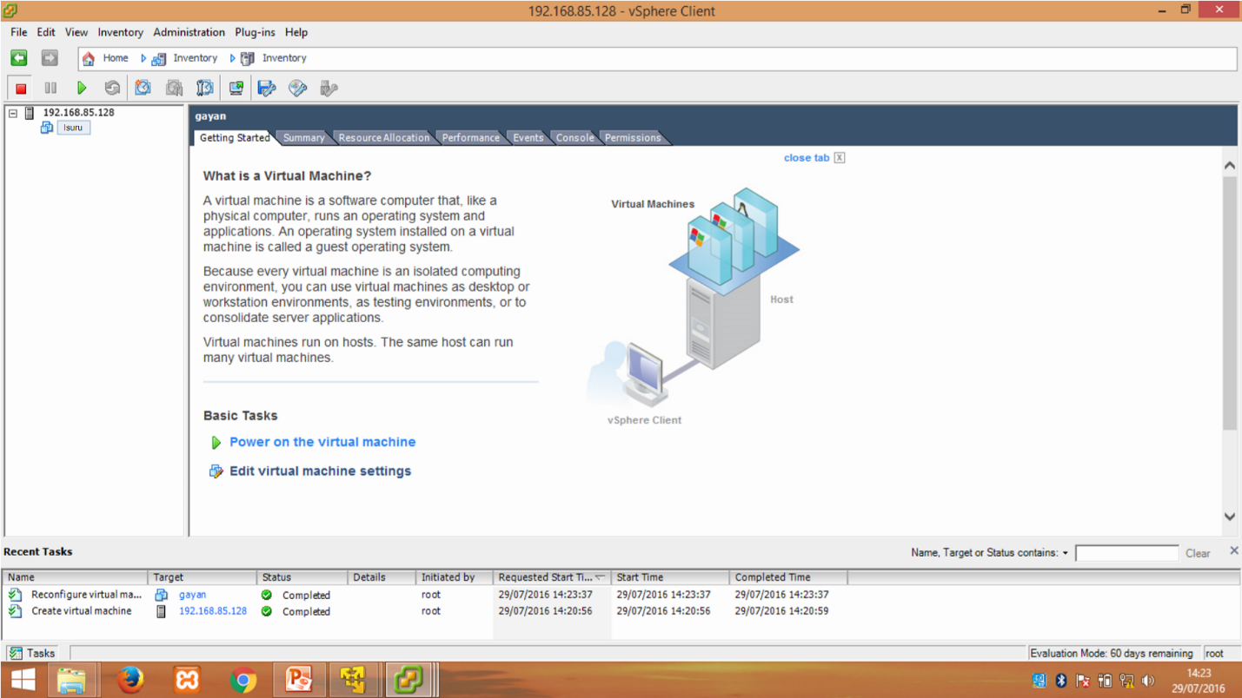

Go to the console you can see KALI Linux is running.

